Distinctive Features of Epistemology of Engineering Design

**M1 vs M1 Pro vs M1 Max - Construction**

Apple's system-on-chips (SoC) are produced by long-time foundry partner TSMC, the same source of Apple's A-series chips.

They're all produced on a 5-nanometer process, which provides several benefits. This includes reducing the physical space of the chip die itself, which reduces the cost-per-chip for wafers, and in turn, the processor itself.

The size also enables lower power consumption compared to other processes, such as the 10-nanometer level that Intel employs in its 2021 chips, as well as potentially higher overall performance.

The benefits of a smaller die work both ways, as it can also enable for a more complex chip to be produced in a specific footprint.

The M1 Max is certainly the biggest chip in the M1 family.

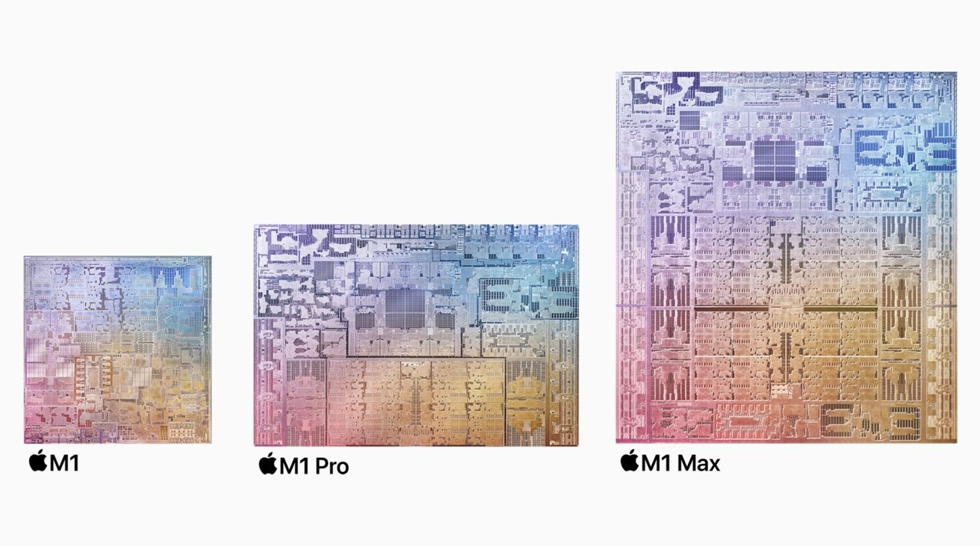

When Apple introduced the M1, it included 16 billion transistors, just above the 15.8 billion used in the A15 Bionic chip. For the new chips, Apple decided to take advantage of the size benefits and think bigger.

The M1 Pro is a chip with 33.7 billion transistors, more than double the original's count. The M1 Max has 57 billion transistors, giving it a 70% improvement over the M1 Pro, which is also 3.5 times the transistors of the original.

The number of transistors that a chip uses doesn't directly translate into performance, as a transistor can be used in varying ways in a chip design. For example, we know that the CPU elements of the M1 Pro and M1 Max are pretty similar, but they differ significantly in GPU core counts, among other alterations.

**[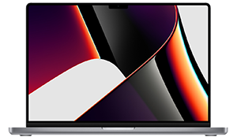](https://prices.appleinsider.com/current-gen)**

**2021 MacBook Pro**

Apple's new MacBook Pro 14-inch and 16-inch comes with three Thunderbolt 4 ports, HDMI port, SDXC card slot, and MagSafe 3 port.

**M1 vs M1 Pro vs M1 Max - CPU, Neural Engine, and Cores**

The M1 was launched in Apple's value-end of the MacBook spectrum, in devices that aren't considered powerhouses, namely the MacBook Air, the 13-inch MacBook Pro, and the Mac mini. As it was framed as being more an entry-level chip, Apple erred towards efficiency and battery life, as well as keeping temperatures manageable for the fan-less MacBook Air.

As such, Apple uses a total of 8 CPU cores, consisting of four "Firestorm" high-performance cores and four "Icestorm" energy-efficient cores. This enabled the chip to switch between the low power consumption cores for menial tasks and the higher performance cores for more intensive workloads.

In the M1 Pro, Apple has two CPU configurations on offer, covering eight cores and ten cores.

The eight-core option includes two high-efficiency "Icestorm" cores along with six high-performance "Firestorm" cores. The ten-core version keeps the two efficiency cores but adds two extra high-performance cores to the existing six, making the total two "Icestorm" and eight "Firestorm" cores.

The M1 Max is longer, and has a higher memory bandwidth than the M1 Pro.

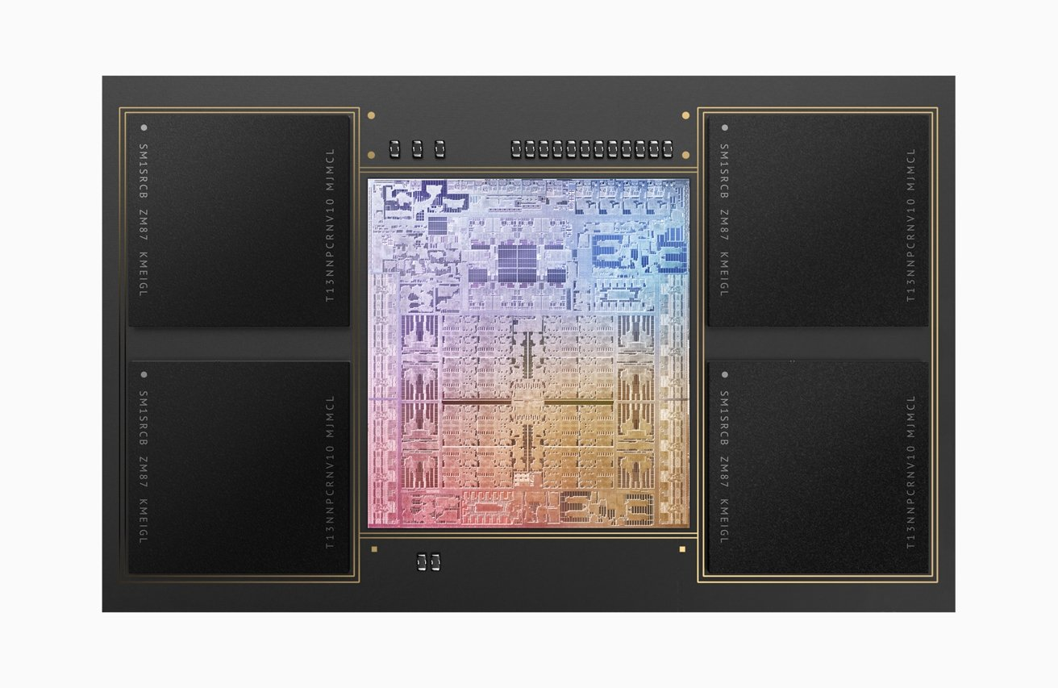

The M1 Max is only available with the ten-core configuration that the M1 Pro offers, of two efficiency and eight performance cores.

**M1 vs M1 Pro vs M1 Max - Unified Memory and Fabric**

The introduction of the M1 also brought with it a new paradigm for memory. Apple's Unified Memory consisted of memory mounted to the SoC, minimizing the distance between memory and chip.

More importantly, Unified Memory used the principle of allowing all SoC components access to the same data store, rather than separating it into different CPU and GPU pools, for example. The idea is to help prevent the unneeded duplication of data in memory to service different SoC elements.

Sitting between the CPU, GPU, Neural Engine, the memory, and other components is Fabric, Apple's term for its connections between all of the components, enabling Unified memory to work in the first place.

Since the integrated GPU uses the same memory as the CPU due to this non-duplication approach, any increases to the Unified Memory pool affect all components equally. Add more memory, and it's both the CPU and the GPU that will benefit.

The M1 Pro has more transistors and GPU cores than the M1.

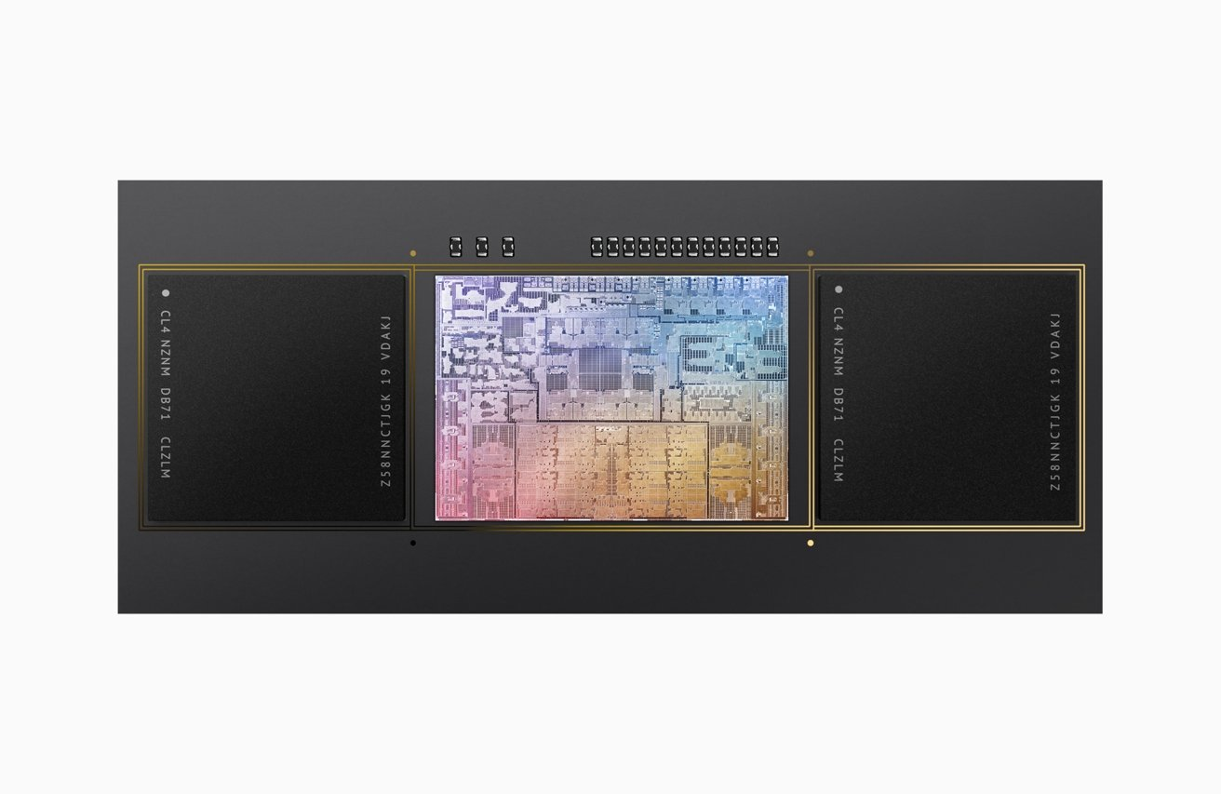

For the M1, Apple included 8GB and 16GB memory options. With the M1 Pro, Apple started at 16GB and raised the maximum to 32GB, while the M1 Max includes 32GB and 64GB options.

It is unclear what precisely the theoretical memory limit could be for the new chips, but for the moment, that maximum is 64GB.

Along with memory capacities, Apple also upgraded Fabric in the newest chips to increase the bandwidth, effectively speeding up the accessing of memory by SoC components. The memory interface was increased to 200GB/s in the M1 Pro and 400GB/s in the M1 Max.

Apple didn't officially announce the memory bandwidth of the M1, but says the M1 Max is "nearly 6x the memory bandwidth of M1." This, in theory, puts the M1 at around 66GB/s of peak memory bandwidth.

In short, the newer chips offer more memory capacities and allow the CPU and other elements to access that memory faster, which can help improve performance.

**M1 vs M1 Pro vs M1 Max - Graphics**

Another relatively tangible performance area for chip comparisons is graphical performance. Apple does not rely on separate discrete GPUs for its new MacBook Pro models, and instead relies on high-core-count GPUs integrated in the SoC.

For the first version, Apple included either a 7-core or 8-core GPU in the M1. Only the MacBook Air had the option of the lesser-count SoC, with all other M1-equipped models using the 8-core GPU.

On the M1 Pro and M1 Max, Apple decided to spend the previously mentioned extended transistor budget on the GPU. The M1 Pro has 14-core and 16-core GPU options, while the M1 Max has 24-core and 32-core versions.

Compared to the M1, Apple says its 16-core M1 Pro is twice as fast. The M1 Max is said to be twice as fast again than the M1 Pro, making it four times faster than the M1 in its 32-core configuration.

**M1 vs M1 Pro vs M1 Max - Media Engine**

With a mind to serving its video-centric customers, the M1 Pro and M1 Max introduce a new element to the SoC that the M1 lacks entirely.

The Media Engine is a section devoted to video processing that preserves battery life. In effect, it's a pile of hardware-accelerated encoding and decoding engines that can handle video more efficiently than the rest of the chip can.

With its video decode and encode engines, the Media Engine can handle H.264, HEVC, ProRes, and ProRes RAW content. It also has dedicated ProPres encode and decode engines to handle footage used in professional video productions.

With film and TV productions relying on premium hardware due to time being a crucial factor in editing, it makes sense for Apple to include these in the M1 Pro and Max.

**M1 vs M1 Pro vs M1 Max - Thunderbolt and Video Out**

Two of the less critical changes to the chips relate to connectivity to other devices.

The M1 could support Thunderbolt 4, but the initial devices offered relatively few Thunderbolt ports to use the standard. Apple rectified the limitation for the M1 Pro and M1 Max by adding more integrated Thunderbolt 4 controllers to add more I/O bandwidth.

In brief, this allowed you to connect more stuff to your Mac, as there's more bandwidth available.

As a byproduct of the I/O bandwidth increase, Apple also made it possible for the new chips to deal with video output much better than before.

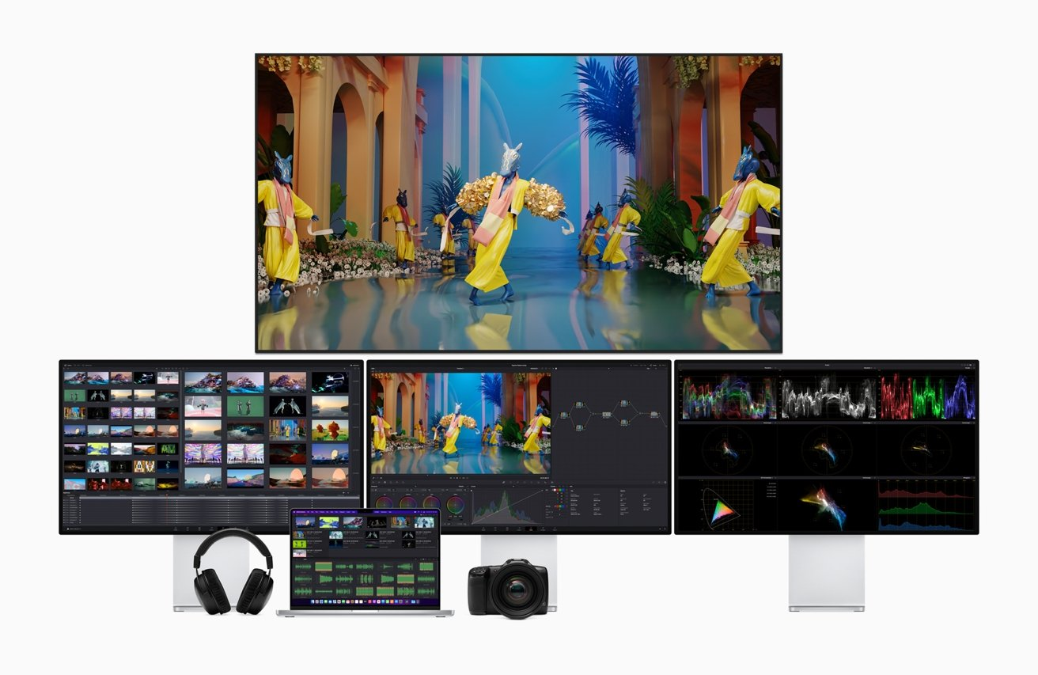

The M1 could only handle two high-resolution displays, which meant the M1 Mac mini could output to two screens at a 6K and 4K resolution. Meanwhile, the M1 13-inch MacBook Pro could only deal with one external 6K display along with its built-in screen.

The M1 Pro improves its external video support, allowing up to two 6K displays to be driven by a MacBook Pro. The M1 Max goes one step further, with it able to deal with up to three 6K screens along with a fourth 4K monitor.